Various network architectures for CartpoleDQN

Normal CartpoleDQN (2 hidden layers)
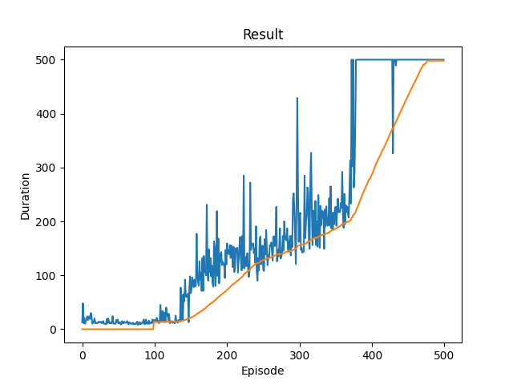

Normal CartpoleDQN (3 hidden layers)
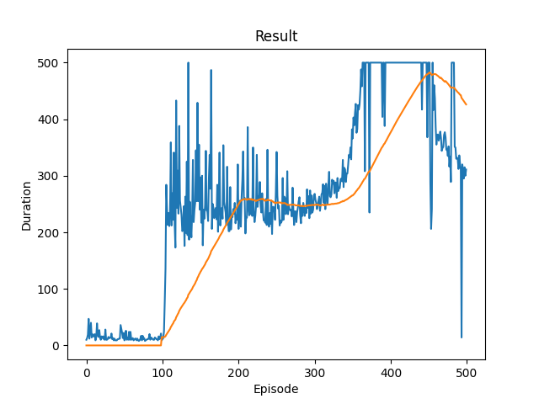
Trained for sensibly more time and showed worse results: it reached a high duration almost at the same episode as the normal NN but showed a higher fall off in the long run maybe due to the discount factor GAMMA (0.99)

CartpoleDQN with GAMMA at 0.10
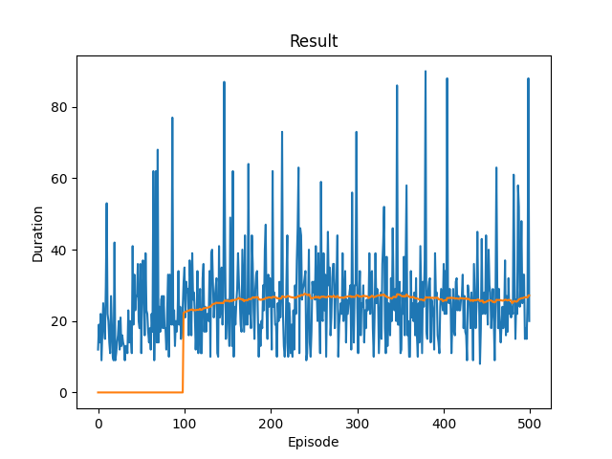
Obviously, training without a sufficient GAMMA parameter leads to the model not being able to successfully predict an efficient policy to maximize the reward on the long run.

CartpoleDQN with batchsize 32
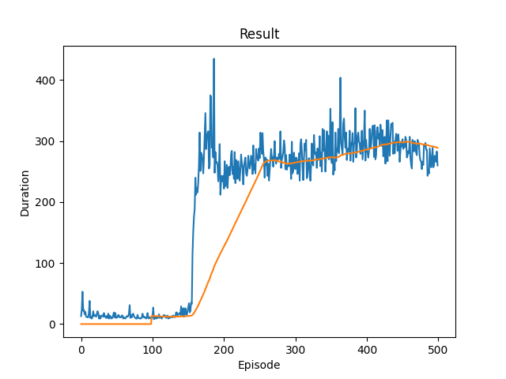
If we reduce the batchsize the exploration phase lasts a bit more than the normal model (150 episodes vs 100 episodes) and after a slightly longer training period, we can observe that neither the peak data nor the mean reaches 500 units of duration.

CartpoleDQN with batchsize 256 (same learning rate)
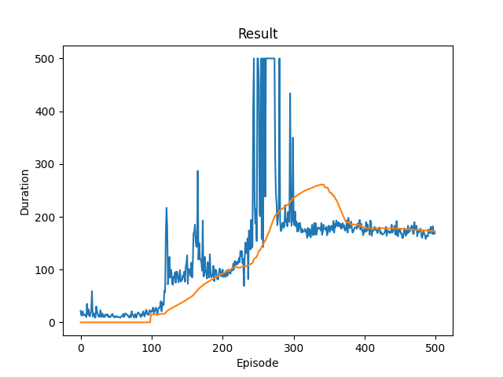
If we change the batch size but maintain the same learning rate (1e-4) we incur in the problem of catastrophic forgetting, where different variability from the batch examples can make the model converge in a suboptimal way
CartpoleDQN with batchsize 256 (Learning rate 5e-4)

Adjusting the learning rate gives a much better result, comparable to the original normal model but much more “noisy” PERCHE?
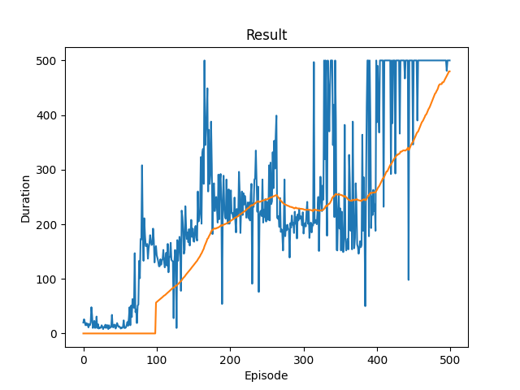

CartpoleDQN with 3 hidden layers, batchsize 32, Learning rate 1e-3 and 1000 episodes
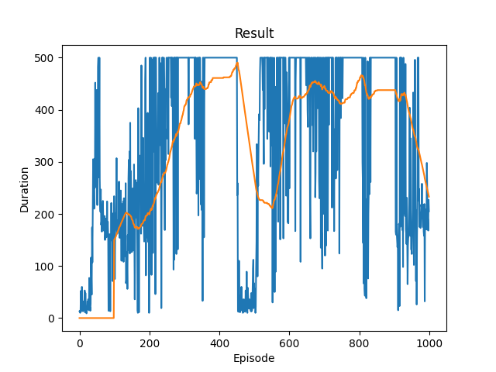
Just for testing purposes, we combined most of the changes in the parameters in one training phase, the results were XXXX

